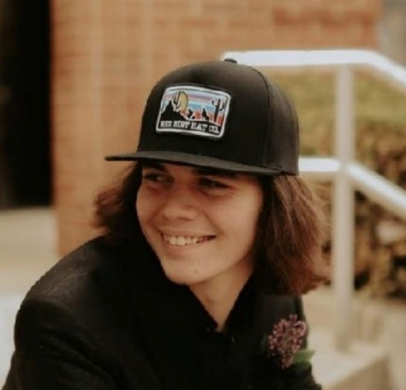  JAXON BROWN FOUNDATION  Our Mission was birthed out of tragedy with intention to honor the legacy of our son, to provide a safe place for those in recovery for substance use disorder. We are committed to helping them rebuild their lives and learn skills to maintain long term sobriety in the setting of community and family.  2 Corinthians 5:17  Therefore, if anyone is in Christ, he is a new creation; old things have passed away; behold all things have become new.  We rely on the generosity of donations and the faithful partnership of God, working through us and others in the community, to bring this Vision to life.  You may contact us at:  (606) 688-0072; (606) 688-0832 | ADDICTION FACTS-WHY IS THIS IMPORTANT?  - A person dies, on average, every 6 minutes in the United States from unintentional drug overdose.  - Kentucky is #13 in the nation in number of drug overdose deaths (all drugs) per population.  - Less than 1 year of sobriety-85% relapse, 1+ year sobriety-50% relapse, 5 years of sobriety significant decrease relapse rate to only 15%.  - More than 75% of drug overdose deaths are related to opioids.  - About 75% of all drug overdose deaths also involve fentanyl.  - 60% of the pills on the street contain a lethal dose of fentanyl.  - 85-90% of those addicted to opioids are unable to maintain recovery.  This is what a lethal dose of fentanyl looks like:    This Photo by Unknown Author is licensed under CC BY-SA | 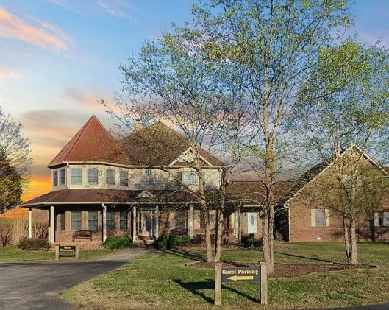  JAXON’S LEGACY LIVING SOBER  WHAT DOES LIVING SOBER LOOK LIKE FOR US?  Our vision is to foster safe, peaceful supportive, and empowering recovery environments where individuals are treated with dignity, respect, and inclusion. We strive to promote personal growth, accountability, and community integration, ensuring every person has access to the resources and opportunities necessary for sustained recovery and well-being.  It is a place of healing and spiritual growth to rediscover purpose, identity, and freedom in Jesus.  We believe in second chances and that Jesus can make all things new.
JAXON BROWN FOUNDATION offering JAXON’S LEGACY LIVING in Cumberland County

